Practice question – Equivalence partitioning and Boundary Value Analysis

For examination system, the result of students are being generated according to the following table.
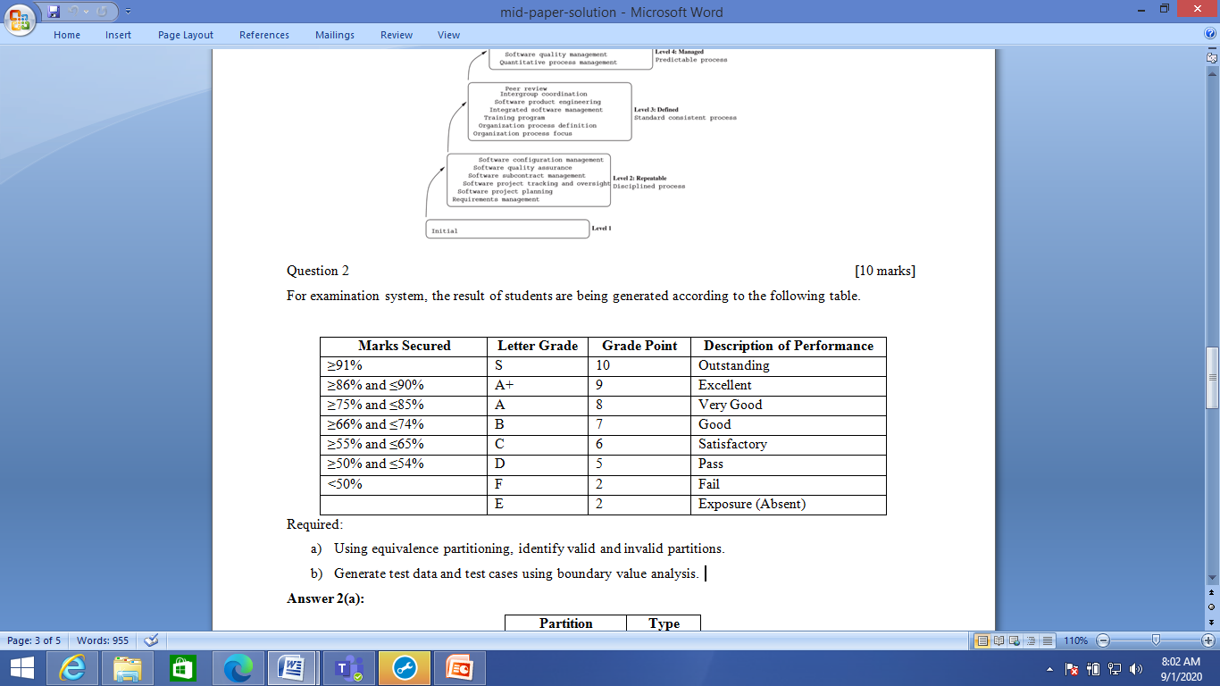

Based on the equivalence partitioning technique, show all valid and invalid partitions and write test cases using equivalence partitioning.

Sample Answer:

Valid and Invalid Partitions:
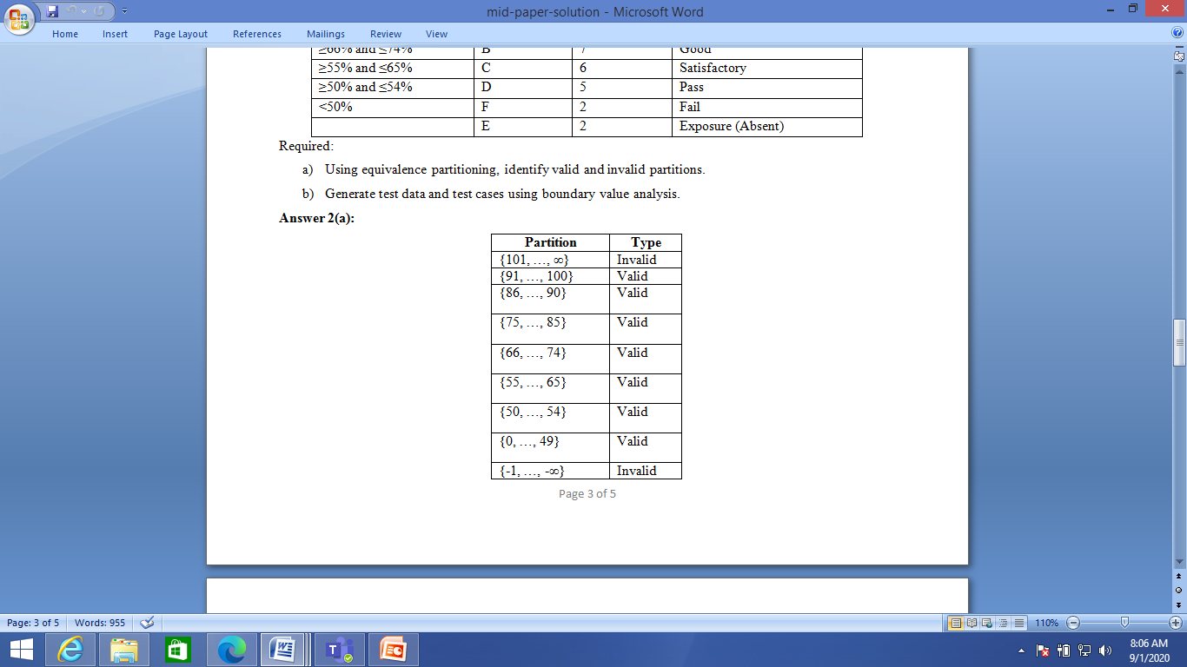
Sample Test cases using equivalence Partitions:
